***E Books***

*User Guide*

|  |  |  |
| --- | --- | --- |
| **Supervisor** | Miss Esha | |
| **Batch** | 2011c | |
| **Group** | E Books | |
| **Serial No.** | **Enrollment Number** | **Student Name** |
| 1. |  | Ahad |
| 2. | 1281592 | Anas |
| 3. |  | Asad |
| 4. |  | Talha |

***USER GUIDE***

**“**Books Spot” This Website is basically based on Books and Top Novels . If you are passionate about Books , so just this website made for you.

**1. Top Layout**

This is the Top of the page.

* User can know about the website by clicking on About Us button
* Users can get touch to the admin by Registering their selves from this page.

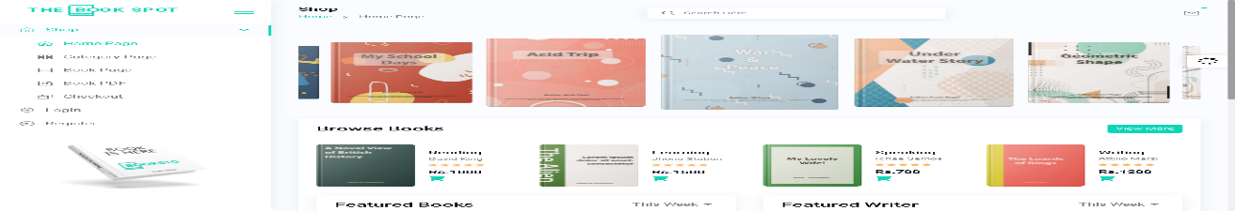

**2.** **Home Page**

* 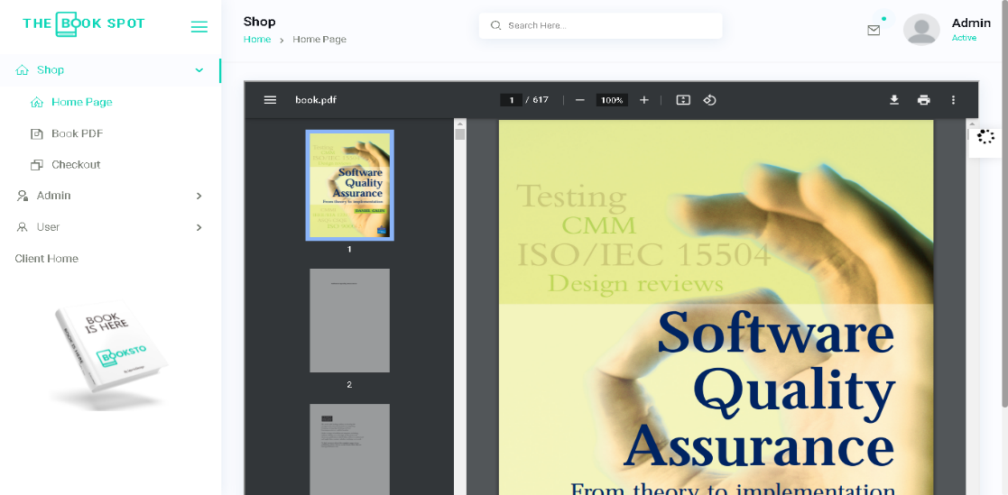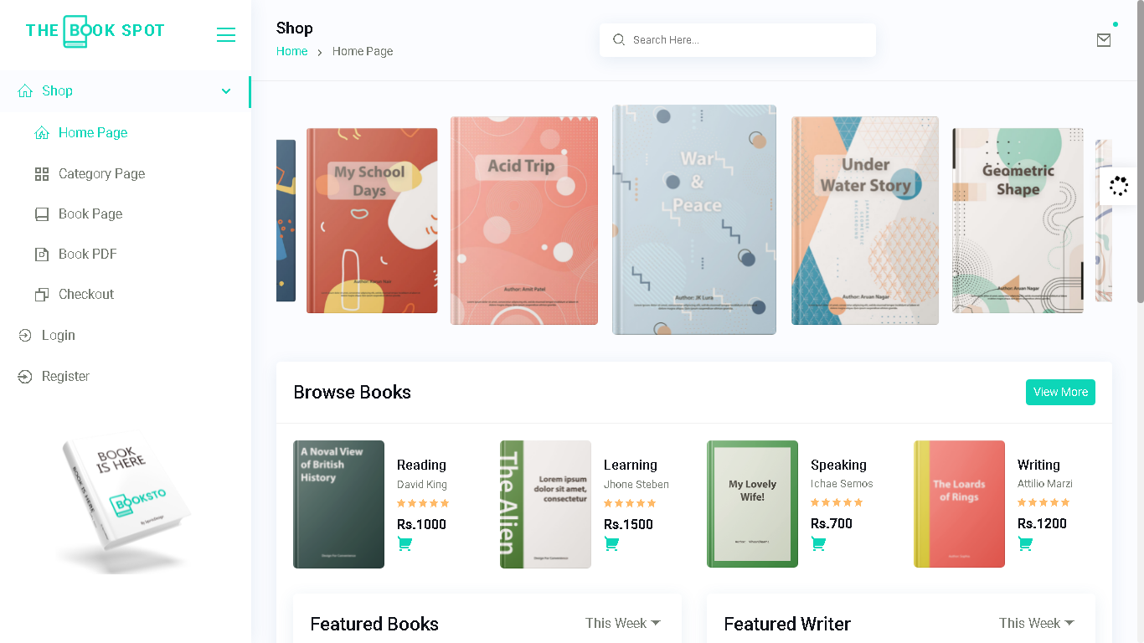This page contain our special items & some ice-creams flavors and their details.

1. **Dash Board Page**

This is the Dash Board Page.

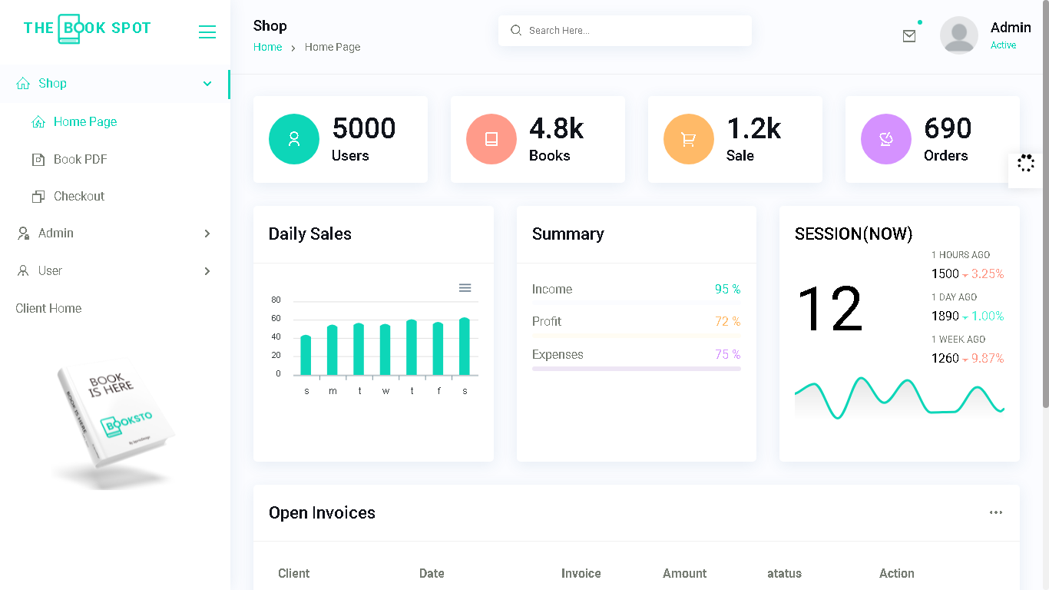

**4.**  **Books Lists Page**

This is the Books List Page.

* In this page users can Choose Their.Favourite Books. .

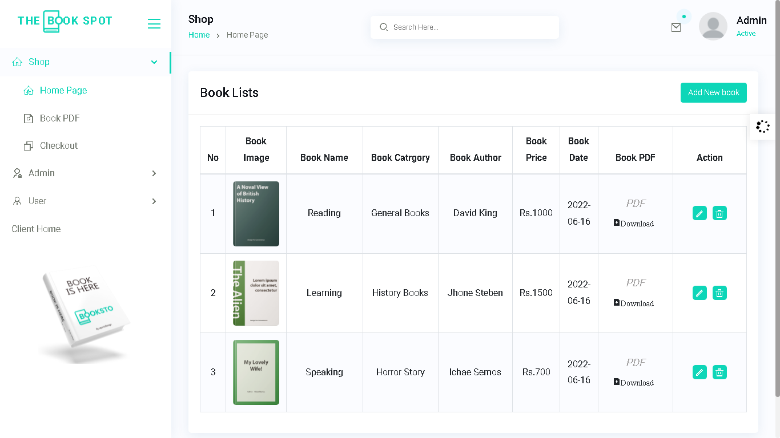

.

**6.** **Login/Register**

* In this page first user can Register their-selves, and then login.
* 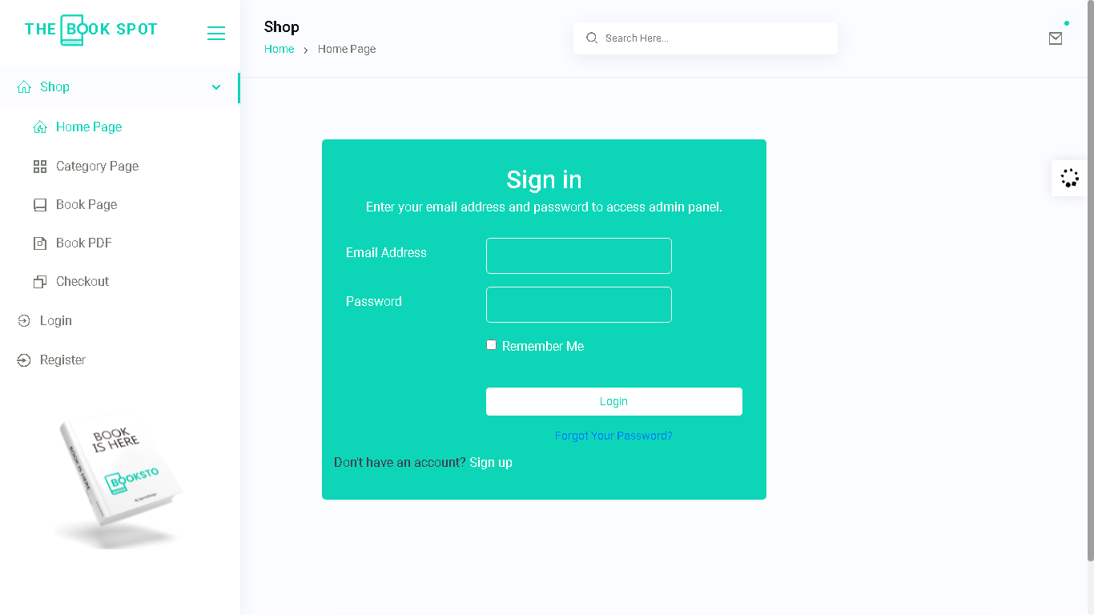After Login user will be redirected to the Home Page and can see the more Books

**Thank You For Reading The Documentation.**